Exp No. 11 Date : 23-08-2019
TRIGGER AND EXCEPTION HANDLING

AIM:
To study PL/SQL trigger and exception handling.

QUESTIONS:

Create a table customer_details (cust_id (unique) , cust_name, address).
Create a table employee_details (emp_id(unique), emp_name, salary)
Create table cust_count (count_row)

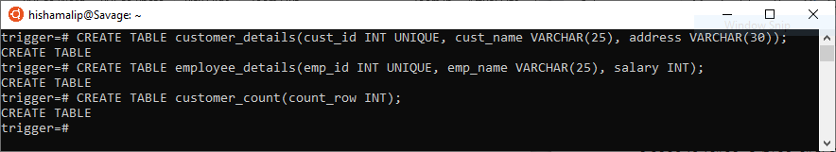

1. Create a trigger whenever a new record is inserted in the customer_details table.

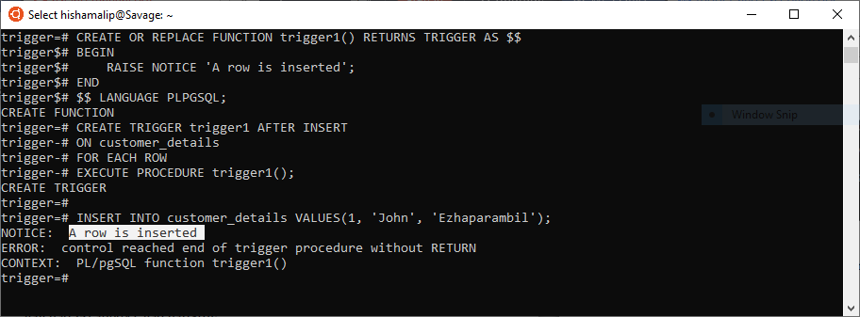

2. Create a trigger to display a message when a user enters a value > 20000 in the salary

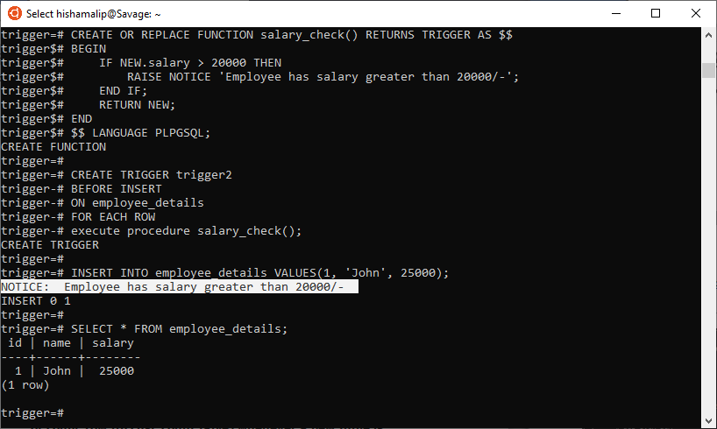

- Create a trigger with respect to customer_details table. Increment the value of count_row (in customer_count table) whenever a new tuple is inserted and decrement the value of count_row when a tuple is deleted. Initial value of the count_row is set to 0.

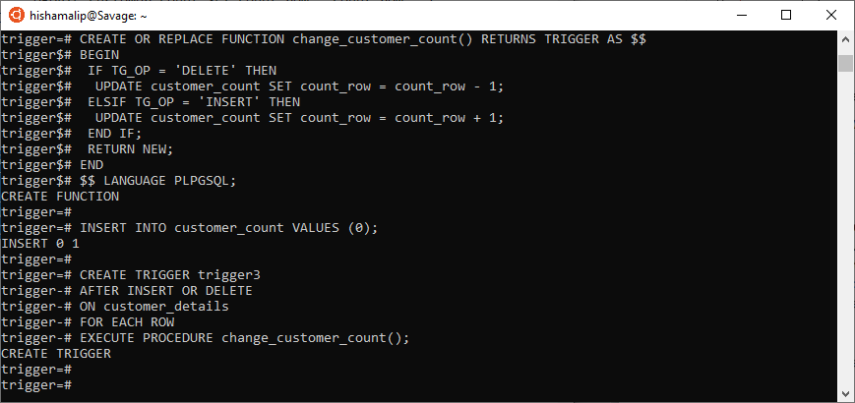

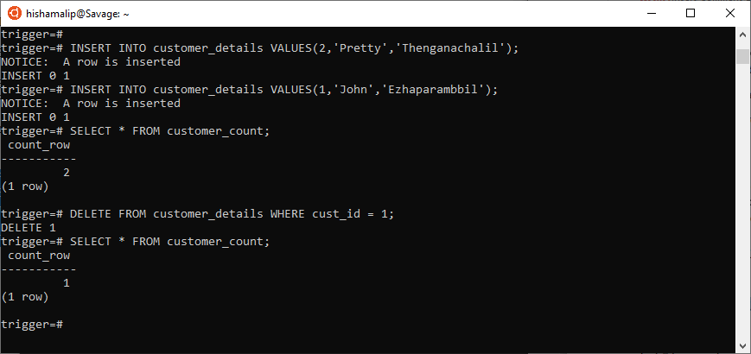

- Create a trigger to insert the deleted rows from employee_details to another table and updated rows to another table. ( Create the tables deleted and updated )
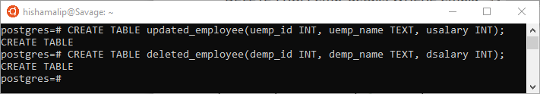

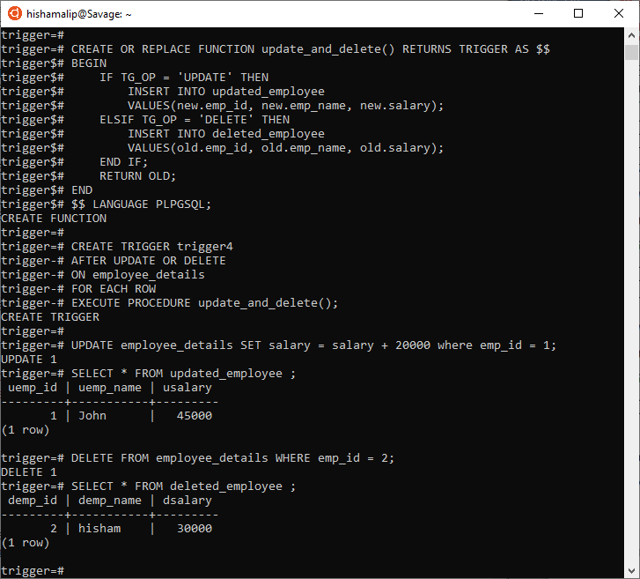

5. Write a PL/SQL to show divide by zero exception

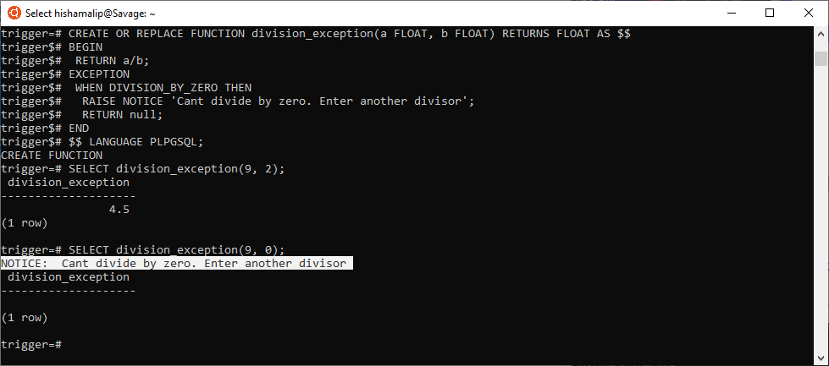

6. Write a PL/SQL to show no data found exception
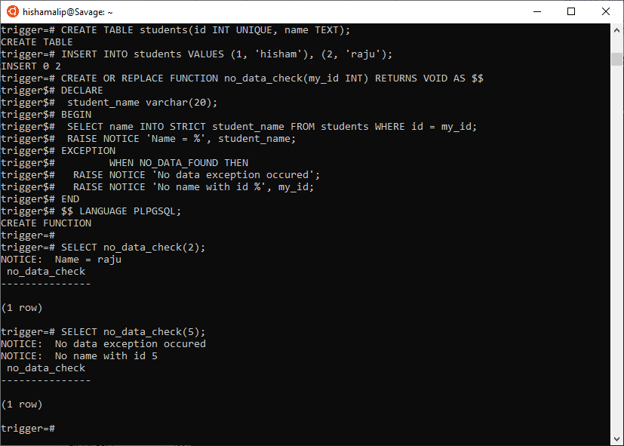
7. Create a table with ebill(cname, prev_eading, curr_reading). If prev_reading = curr_reading then raise an exception ‘Data Entry Error’.

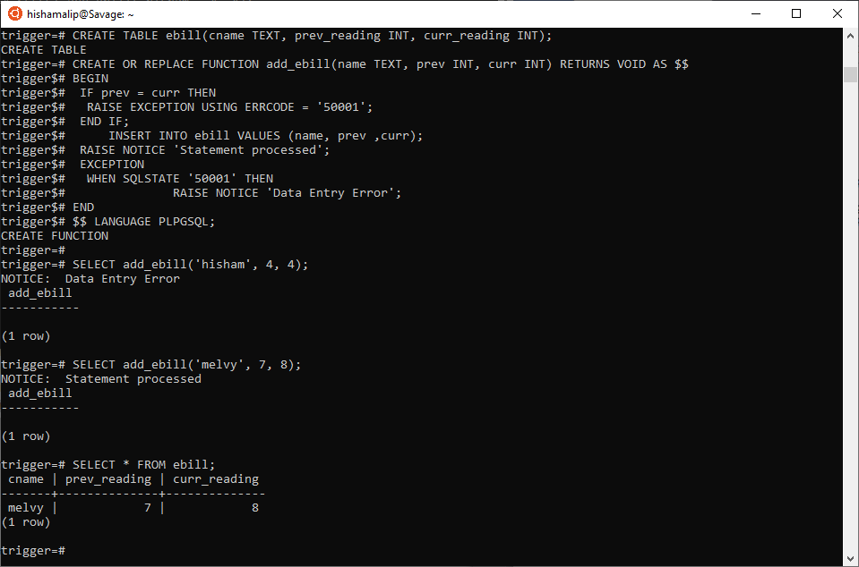

RESULT:
The PL/SQL program was executed successfully and the output was obtained.

